CUSTOMER DATA |  |  |  |  |  |  |  |  |  |  |  |  |  |  | INTERTEK DATA
Name: |  |  | ADNOC Onshore  P.O. Box 270, Abu Dhabi, UAE |  |  |  |  |  |  |  |  |  |  |  | Intertek Project No.
Address: |  |  |  |  |  |  |  |  |  |  |  |  |  |  | Client P.O./I.O. to Intertek: |  |  |  |  | -
Attn: |  |  | Islam Khalifa |  |  |  |  | Phone: |  |  | +971 0567857160 |  |  |  | Requisition No:
E-Mail: |  |  | i.khalifa@adco.ae |  |  |  |  |  |  |  |  |  |  |  | Date of Order: |  |  |  |  | 21-Sept-26
Copies to: |  |  |  |  |  |  |  |  |  |  |  |  |  |  | Intertek Contract Coordinator: |  |  |  |  | Chethan Ramesh
SUPPLIER/SUB-SUPPLIER DATA |  |  |  |  |  |  |  |  |  |  |  |  |  |  | INSPECTION INFORMATION
Inspection  Performed: |  |  | With Customer Supplier With Sub-Supplier |  |  |  |  |  |  |  |  |  |  |  | Date(s) of Visit(s): |  |  |  |  | 21/09/2026
P.O. No:  P-AiP5-12-IC15-003 |  |  | Change No: N/A |  |  |  |  |  |  | Requisition No: N/A
 |  |  |  |  |  |  |  |  |  |  |  |  |  |  | Date of Previous Visit: |  |  |  |  |  | 19/09/2026
Supplier: |  |  | KSB MIL CONTROLS LIMITED Meladoor, Annamanada - 680741, Kerala, India. |  |  |  |  |  |  |  |  |  |  |  | Date of Next Scheduled Visit: |  |  |  |  |  | N/A
 |  |  |  |  |  |  |  |  |  |  |  |  |  |  | P. O. Status: |  |  | Complete Incomplete
Supplier Job No: |  |  |  |  |  |  |  |  |  |  |  |  |  |  | Project Name:
Location: |  |  | Meladoor, Annamanada - 680741, Kerala, India |  |  |  |  |  |  |  |  |  |  |  | EPC for SE AiP5 Project (On plot) - ASAB/SAHIL (Package 1)
Primary Contact: |  |  | Mr. Alex Davis (KSB MIL Contract Management) |  |  |  |  |  |  |  |  |  |  |  | Materials/Items Inspected:  Body and Trims
Phone: | +91 480 2695832 |  |  |  | E-mail: |  | Alex.Davis@ksb.com
Sub-supplier: |  |  | xxxxxxxxxxxxxxx
Sub-Supplier Job No: |  |  | xxxxxxxxxxxxxxx
Location: |  |  | xxxxxxxxxxxxxxx
Primary Contact: |  |  | xxxxxxxxxxxxxxxxx |  |  |  |  |  |  |  |  |  |  |  | Pre-Inspection Meeting Summary Attached: |  |  |  |  |  |  | Yes No
Phone: | xxxxxxxxxxxxxxxxxx |  |  |  | E-mail: |  |  | xxxxxxxxxxxxxxxxxx |  |  |  |  |  |  | Summary Report Attached: |  |  |  |  |  |  | Yes No
INSPECTION DISPOSITION: |  |  |  | Accept |  |  | Nonconformance(s) Identified |  |  |  |  |  |  |  |  | Placed on Hold |  |  |  | Other (Explain)
INSPECTION SUMMARY AND CONCLUSION:
The inspection was conducted in accordance with ITP No. CV-L2-4441 QAP R3/SO REV NO:F, covering the inspection of Body , Bonnet and trims . All inspection activities were carried out as per ITP Clause Nos 3.1 (a),3.1 (b).3.2(c),4.5(a).

Result: Acceptable
RECOMMENDED ACTION:
4.6(b) Primer coat DFT:- To be offered
INSPECTION TIME: |  |  | DAYS  HOURS |  |  | 8 |  |  |  |  |  | TRAVEL HOURS: | 5 |  |  |  |  |  | DISTANCE:  MI KM |  |  |  | 160 KM
Technical Specialist: |  | XXXXXXX |  |  | Date: |  |  |  | XXXXXXXX |  |  |  |  | Project Coordinator:
This report is made solely on the basis of the Client’s instructions and/or information and materials supplied. It is not intended to be a recommendation for any particular course of action. Intertek does not accept a duty of care or any other responsibility to any person other than the Client in respect of this report and only accepts liability to the Client insofar as is expressly contained in the terms and conditions governing Intertek's provision of services. Intertek makes no warranties or representations either express or implied with respect to this report save as provided for in those terms and conditions.

- ATTENDEES

NAME | COMPANY REPRESENTED | TITLE
Adarsh MS | Intertek OBO ADNOC | Inspection Engineer
Sasikumar IL | KTIME OCO CPECC | Inspection Engineer
Sabari Giri | TUV SUD OBO Vendor | Inspection Engineer

- MATERIALS

  - GENERIC MATERIALS

TAG / EQPT NO. | DESCRIPTION
11-14-PCV-6712-09B | 2'',#300 RF ASTM A216 Gr WCC
11-15-PCV-6704-09B | 2'',#300 RF ASTM A216 Gr WCC

  - MATERIALS INSPECTED

PO ITEM NO. | TAG / SERIAL NO. | PRODUCT / MATERIAL / ITEM NAME | ORDERED QUANTITY | PRESENTED THIS VISIT | ACCEPTED  THIS VISIT | QUANTITY ACCEPTED TO DATE
 | 11-14-PCV-6712-09B | Body |  | 1 | 1 | 1
 | 11-15-PCV-6704-09B | Body |  | 1 | 1 | 1
 | 11-14-PVC-6712-09C | Body |  | 1 | 1 | 1
 | 1127950 | Plug |  | 1 | 1 | 1
 | 1123840 | Plug Stem |  | 1 | 1 | 1
 | 1123708 | Seat ring |  | 1 | 1 | 1
 | 1112738 | Body |  | 1 | 1 | 1
 | 1112737 | Body |  | 1 | 1 | 1
 | 1124200 | Bonnet |  | 1 | 1 | 1

- DOCUMENTS USED

DOCUMENT NO. | REVISION | TITLE | APPROVAL STATUS
RFI No: RFI-P30350-P-AiP5-12-IC15-003-067 | 1 | RFI | -
CV-L2-4441 QAP R3/SO | F | ITP | 2

- SCOPE OF INSPECTION

ITP LINE NO. | ITP ACTIVITY DESCRIPTION | ITEMS | RESULTS | CLAUSE
3.1 (a) | Shell Pressure Test (Without primer) | 11-14-PCV-6712-09B, 11-15-PCV-6704-09B, 11-14-PVC-6712-09C | Acceptable | W
3.1(b) | DPT | 1127950,1123840,1123708 and 1112738. | Acceptable | W
3.1(c) | PMI | 1127950,1123840,1123708 and 1112738. | Acceptable | W
4.5(a) | Surface preparation, Dust Profile and Salt contamination check | 1112737 and 1124200 | Acceptable | WR

- EQUIPMENT AND INSTRUMENTATION USED (TO BE SUPPLIED BY SUPPLIER)

EQUIPMENT / INSTRUMENT DESCRIPTION | SERIAL NO | CALIBRATION CERT. NO. | EXPIRY DATE
Stop Watch | MQC599 | SLT/26/02/415/008 | 27/02/2027
Cleaner | 25M01
Penetrant | 24D27
Developer | 26D17
Pressure Test machine | E120 |  | 01/09/2027
Dial Thickness Gauge | MIL 2L 1215 | RMTL/01/3261000042-A3 | 02/04/2027

- INSPECTION DETAILS
Visited KSB Mils Ltd and the inspection was conducted according to ITP- P30339B-30-99-52-4607
Day 1 (18/09/2026)
FAT Conducted for the
1)Valve SL No: 26000788 & 26000789, Job No (CD77E001), Tag 11-14-PCV-6712-09B & 11-15-PCV-6704-09B
ITP Clause 3.1 (a):- Contacted Shell and conducted a pressure test on the body (1112737 and 1112738). No leakage was observed during the test. Hence, the items were found acceptable.
Day 2(19/09/2026)
1) Valve SL NO:-BV260027 Job No(CD77E002), Tag:- 11-14-PVC-6712-09C
ITP Clause 3.1 (a):- Contacted Shell and conducted a pressure test on the body (1129104). No leakage was observed during the test. Hence, the items were found acceptable.
2)Item SL no:- 1127950,1123840,1123708 and 1112738.
ITP Clause 3.1 (b):- DPT was conducted after machining on the body, plug ,plug stem and Seat ring. No defects were detected during the inspection.
ITP Clause 3.1 (c):- Material check, PMI check was conducted on the body plug ,plug stem and Seat ring, and the material was verified and found to be acceptable.

Day 3(21/09/2026)
1) Item SL no:- 1112737 and 1124200
ITP Clause No.: 4.5 Surface preparation and Painting
a)Blasting /Surface preparation checking was conducted and verified to the grade specified in the Applicable Painting System with reference to AGES and painting procedure
Surface Preparation:
Surface preparation was inspected and verified against the approved data sheets P30350-12-99-40-4634 / P30350-11-99-40-4679 and approved procedure AGES-SP-07-004. The surface preparation was found to be in accordance with the approved requirements and accepted.
Dust Profile:
Dust profile inspection was carried out and verified in accordance with the approved data sheets P30350-12-99-40-4634 / P30350-11-99-40-4679 and AGES-SP-07-004. The results were found acceptable and in compliance with the approved requirements.
Salt Contamination:
Water Soluble Salts test was conducted and verified against the approved data sheets P30350-12-99-40-4634 / P30350-11-99-40-4679 and AGES-SP-07-004. The test results were found within the specified acceptance criteria and accepted.

- NON-CONFORMANCES

NCR # | DESCRIPTION | DATE RAISED | DATE CLOSED
 | - | - | -

- QUALITY OBSERVATIONS

Item No. | Material Inspected: Control Valve
Observation Type: Positive Negative |  | Criticality: Critical Non-Critical
Category: Dimensional |  | Sub-Category: Dimensional Inspection
Further Comments:

Item No. | Material Inspected: Choose an item.
Observation Type: Positive Negative |  | Criticality: Critical Non-Critical
Category: Documentation |  | Sub-Category: Incomplete Documentation
Further Comments:

- ATTACHMENTS TO THIS REPORT

- As Per Attached Annexure list
- Calibration Certificates Reviewed

- PHOTOGRAPHS
Inspection Photos.
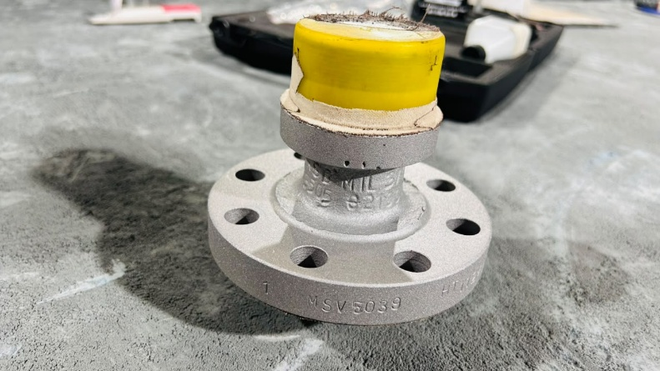 | 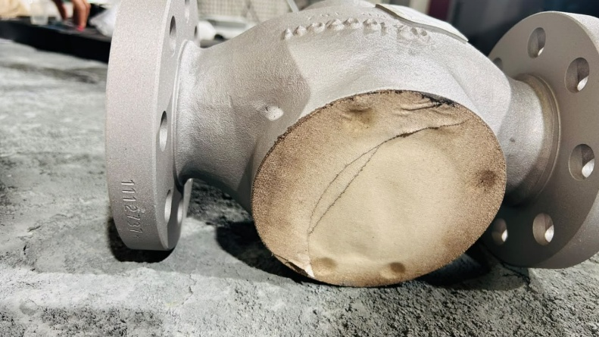
Bonnet | Body
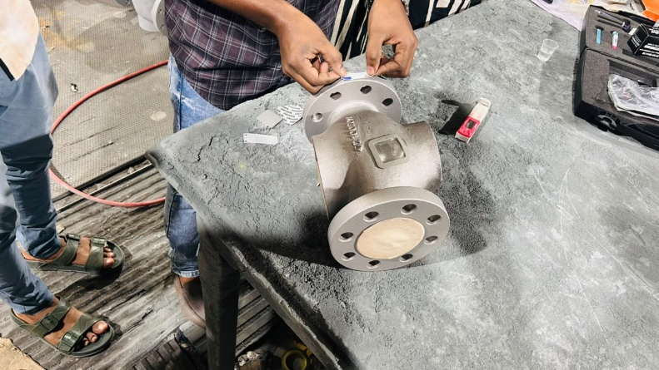 | 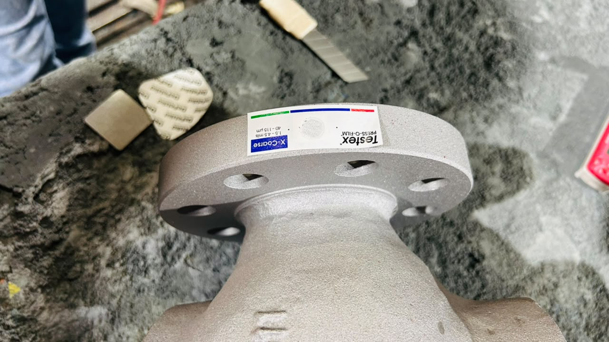
Profile Check | Profile check
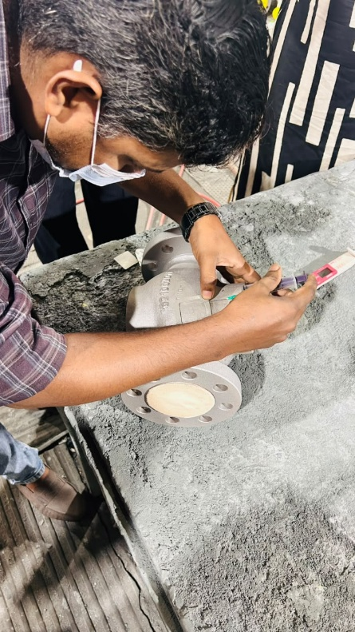 | 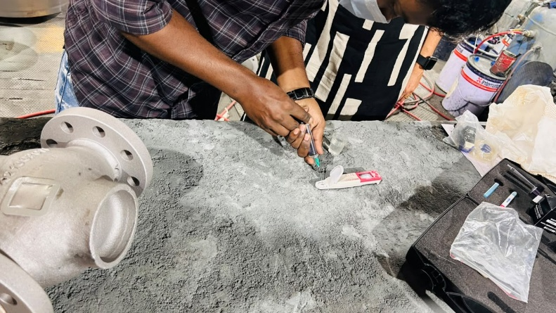
Salt test | Salt Test
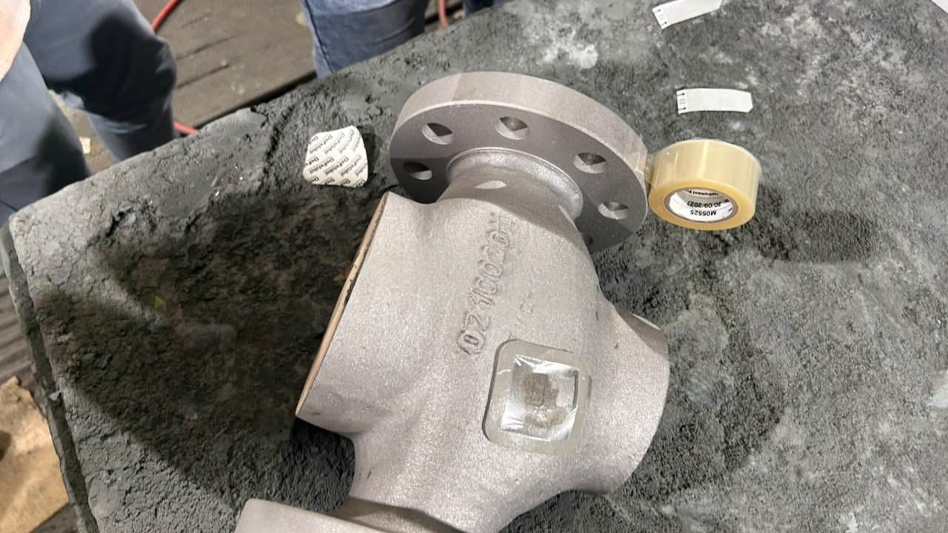 | 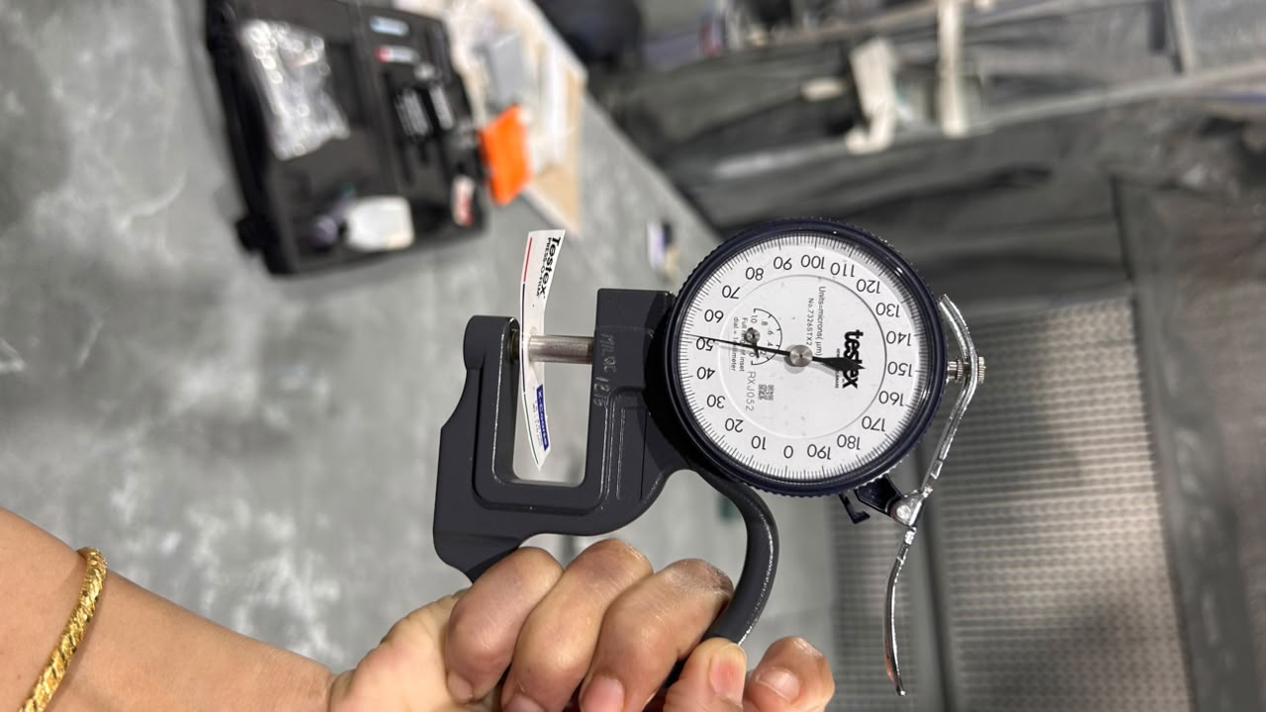
Adhesion test | Profile Test
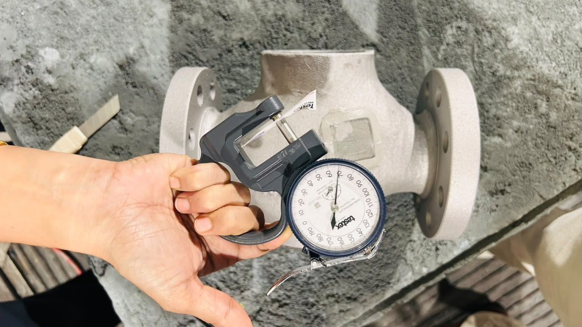 | 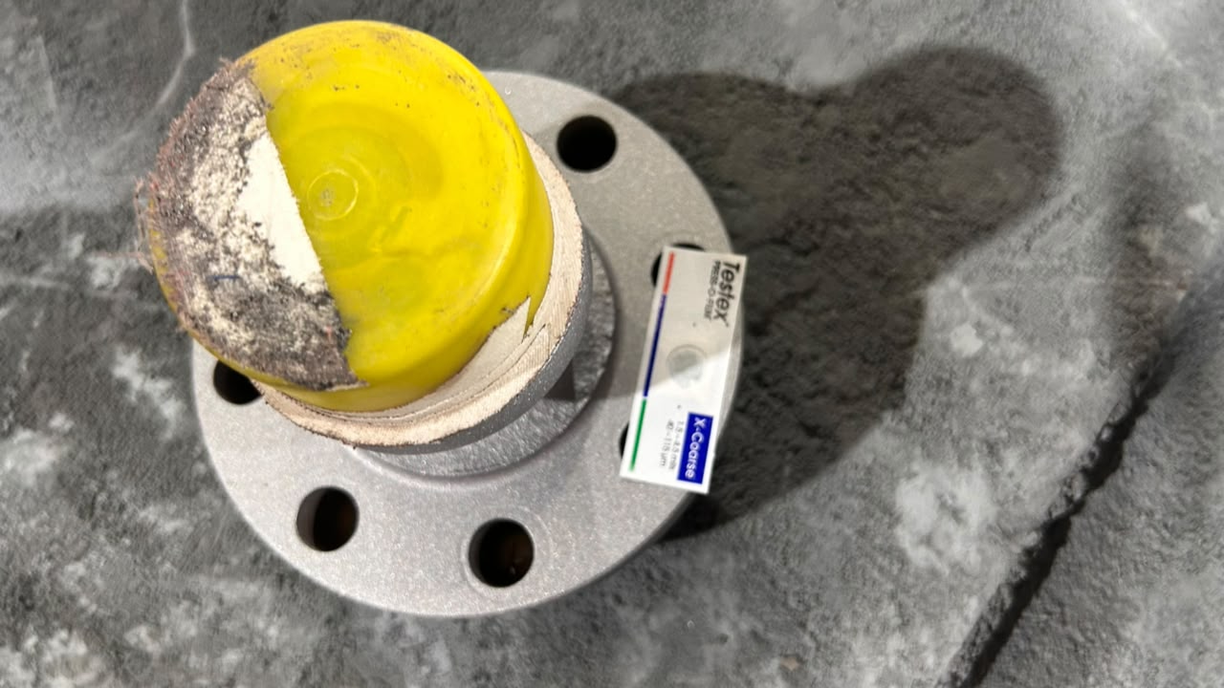
Profile Test | Profile Test

